# Where to find and how to run.

# Simulations

Maneater location: C:\Users\sarantis\CLionProjects\ManEater2

* To run Open Clion.
* Click on the top left of the application and select ManEater2, if not there then click on open and find the project directory.
* 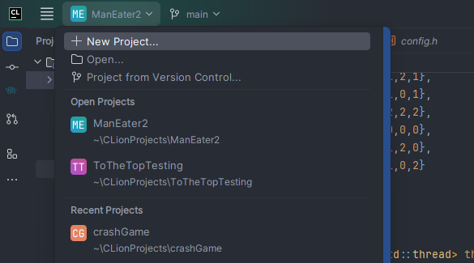
* After selected while in any file you can click on the green triangle and run the file.
* 

To The Top location: C:\Users\sarantis\CLionProjects\ToTheTopTesting

To the top can be run the same way. Directory named ToTheTopTesting is the main directory that stores the latest version.

# Server:

Documents on how to build a server are found in the tequity-metawin-slots slack channel. Local and latest version is of the server is stored in:

C:\Users\sarantis\Documents\metawin-game-servers

Can be worked on with Visual Studio Code. To run general stats

PS C:\Users\sarantis\OneDrive\Desktop\metawin-game-servers> npx slotify-gdk stats -g games/tothetop -i “number of iterations” -c 20 --bet 1

Updating server

docker build -t ghcr.io/slotify/games/metawin:v0.1.29 .

Push update

docker push ghcr.io/slotify/games/metawin:v0.1.29

Server version should also be updated in packages.json file within the metawin-game-servers directory.

